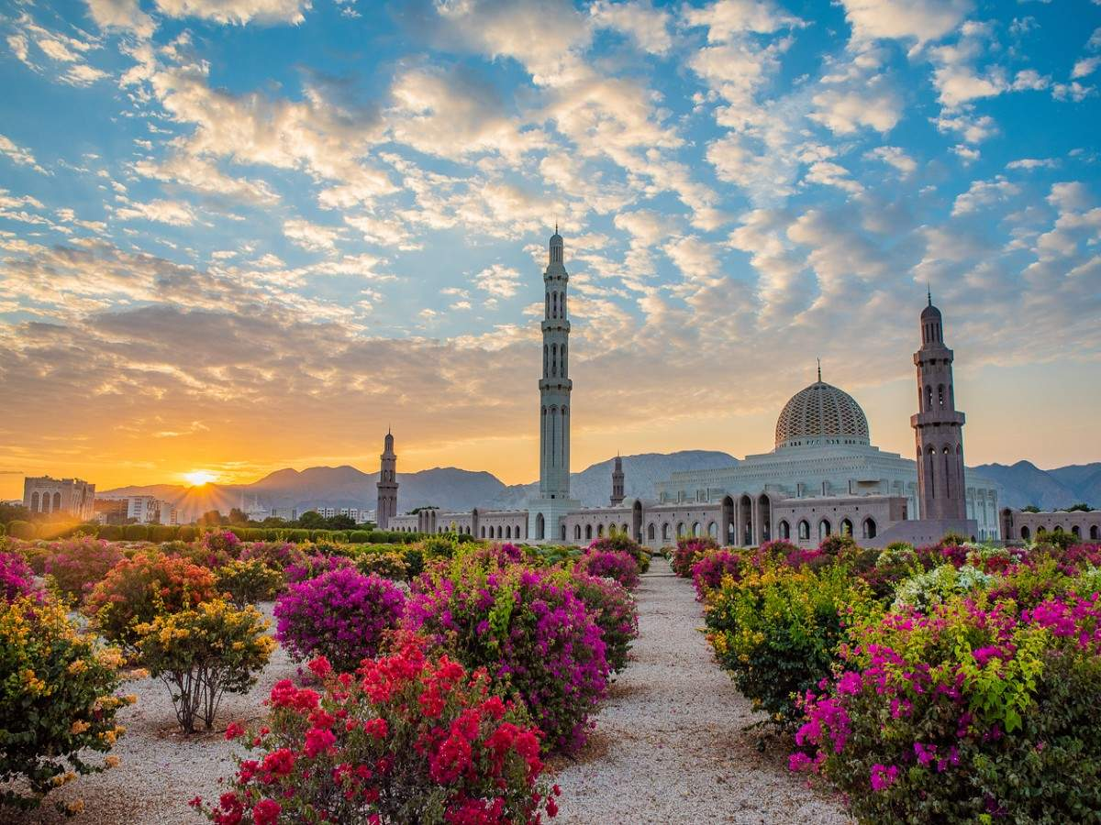

Itinerary Name: Oman in Regular (Fixed Departure)
Number of pax: Minimum 02 Adults
Travel Duration: 7 Days & 6 Nights

Itinerary:

Day 01: Arrival in Muscat
Arrival at Muscat International Airport. Visa procedures will be completed. Luggage collection and chauffeur-driven transfer to your hotel in Muscat. Overnight at the hotel.
Overnight in Muscat

Day 02: Half Day Sightseeing of Barkha / Nakhl / Rustaq (B, - D)
Breakfast at the hotel. We will then head towards Barkha, in the Batinah area. Barkha is a small fishing village where we can visit the market that opens every morning. From there we will head to Nakhl, a small village that houses one of Oman's forts, surrounded by an-oasis of palm trees. We will visit Nakhl Fort, also known for its hot springs in the area. We will then continue to Rustaq, which has one of Oman's most important forts, built in the 12th century, where we can take a photo. Finally, we will return to Muscat where we will have the rest of the afternoon free. Dinner included at the hotel.
Overnight in Muscat

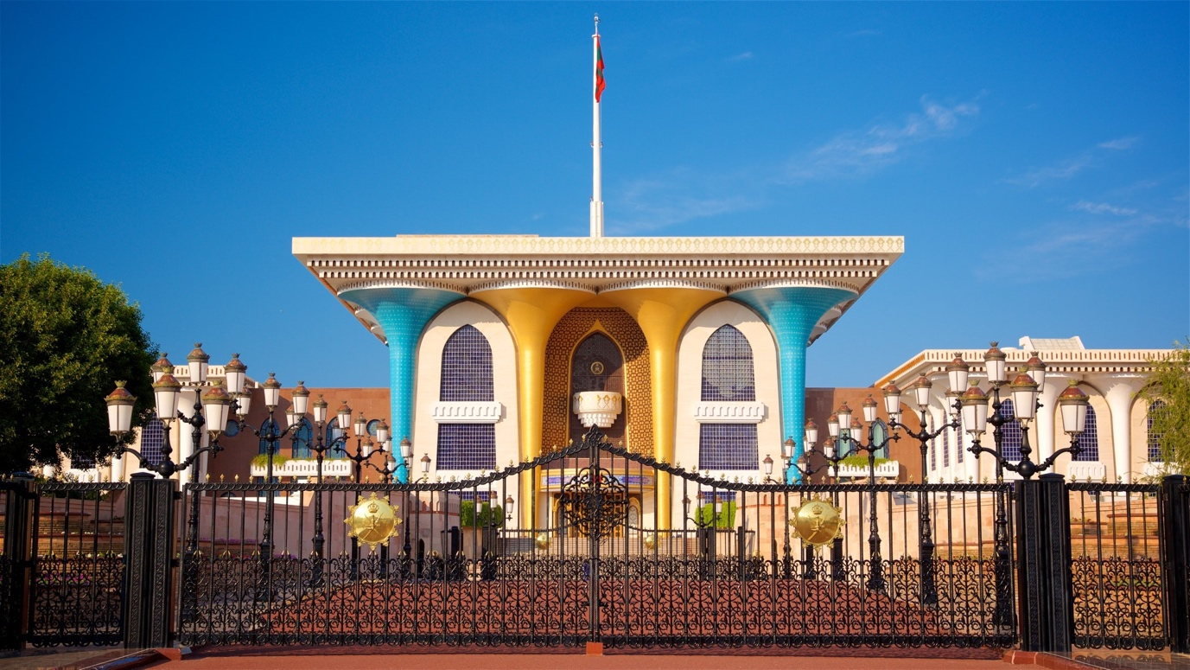

Day 03: Half Day Muscat Tour (4 hours total) (B, - D)
Breakfast at the hotel. Reception in the lobby to begin our city tour of Muscat. The first visit will be to the Grand Mosque (open to visitors Saturday through Thursday from 8 to 11 am), the largest mosque in the country, with beautiful artwork, chandeliers, and a single-piece carpet covering the entire prayer hall, which measures approximately 4,260 square meters. After the visit, we will continue our journey to Al Alam Palace (photo stop), flanked by the two Portuguese forts, Jalali and Mirani. We will visit the Bait Al Zubair Museum to understand a little more about Omani culture and history. We will then continue our tour along the Corniche promenade to Mutrah Souq, one of the oldest souks in Oman. The narrow alleys of the souk and the mystical scent of incense and sandalwood in the air are typical of this souk. The remainder of the afternoon is free. Dinner included at the hotel.
Note: Children under 10 are not allowed to enter the Grand Mosque. Women must wear long clothing and a headscarf. Men must cover their arms and legs. The mosque is open Saturday through Wednesday from 8:00 a.m. to 11:00 a.m.
Overnight in Muscat

Day 04: Visit of Nizwa, Jabreen, Bahla and Al Hamra (B, - D)
Breakfast in the hotel. Departing Muscat, we will stop at the Amouage perfume and essence factory, the quintessential national brand that continues the tradition of Arabic perfume, whose perfumes are claimed to be the most expensive in the world. We will then head to Nizwa, which was the capital of the Al-Julanda dynasty in the 6th and 7th centuries. Today, it remains a popular tourist attraction with its historic buildings and imposing fortress. We will visit the Nizwa Fort with its enormous round tower built in the 17th century to defend the route into the
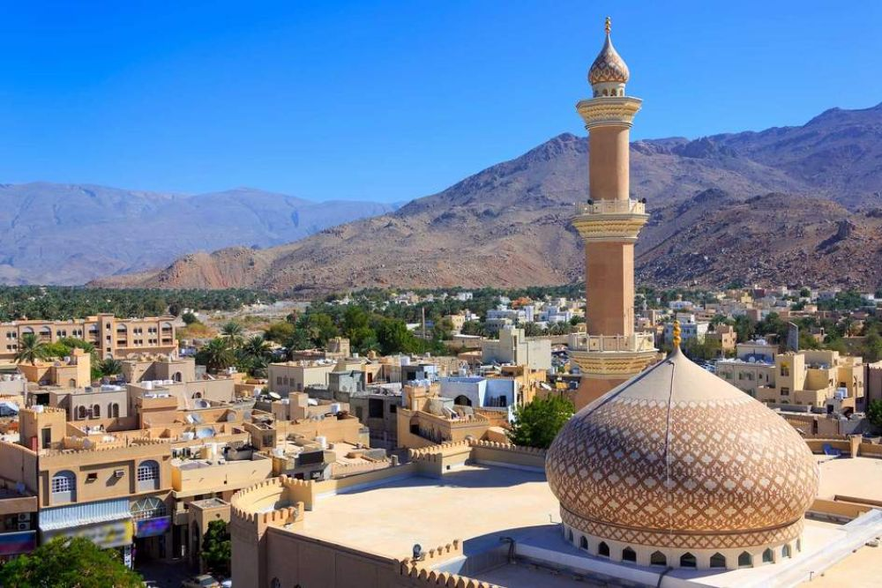

interior. From the top of the tower, you can get a panoramic view of Nizwa. From here, it is a short walk to the Nizwa Souq, which is famous for its intricately hand-carved "khanjar" and ornately designed silver jewelry. A unique goat and cattle auction is held here on Fridays. The atmosphere is electric. We will then head to visit Jabreen Castle. Stopping in Bahla for a photo opportunity at the Bahla Fort, a World Heritage Site. Arrive in Jabreen to visit Oman's finest castle, built in the late 17th century and the seat of Oman's learning. This castle has extremely well-planned layouts, with space for the Wali, the ladies' bath, the kitchen, the Majlis, etc. Most of the ceilings are decorated with beautiful paintings featuring Islamic motifs.
Dinner in the hotel.
Overnight in Nizwa

Day 05: Visit Nizwa, Al Minsifieh, Al Mudayrib, Wahiba Sands (B, - D)

Breakfast at the hotel. Afterwards, we will visit the Nizwa souk before heading to Wahiba Sands. During the journey, we will pass through the villages of Minsifieh and Al Mudayrib, which have maintained their traditional atmosphere and character, where we will see old trading towns. Once we reach the Wahiba Sands Desert, we will use 4x4 vehicles to travel across the dunes to the desert camp. Time to relax and enjoy the desert. Dinner and overnight stay at the camp.

Overnight in Wahiba Sands

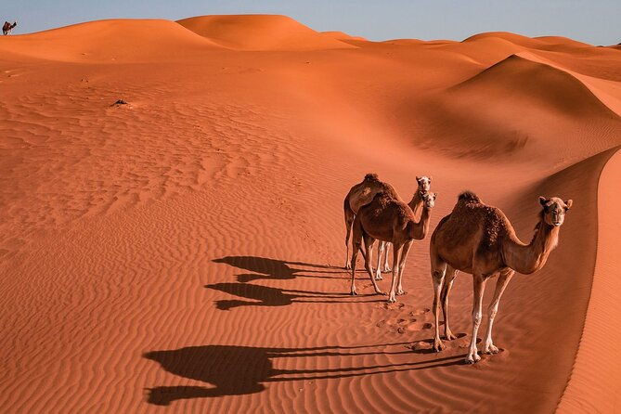

Day 06: Visit of Wahiba, Wadi Bani Khalid, Ras Al Jinz/Turtles (B, - D)

Breakfast at the hotel. After enjoying the desert sunrise, we will return to the town of Biddiyah again in 4x4 vehicles. We will then continue by bus to Wadi Bani Khaled in the Hajjar Mountains, one of the most impressive natural wadis in the Sultanate of Oman, a valley covered by mountains, with palm groves and idyllic rivers that form natural pools where we can swim. We will continue to Sur, the capital of the Sharqiya region. Early dinner at the hotel. This evening, we will visit the RAS AL Jinz Scientific Center (www.rasaljinz-turtlereserve.com) where we will visit the turtle museum. Later, we will see the giant turtles that come here at night to lay their eggs in the sand, after a journey of several thousand kilometers across the seas and coasts of Asia and Africa. The best time for this activity is from May to September. Overnight at the hotel. Dinner included.

Important: If you are unable to see turtles during your visit, there is no refund.

Overnight in Sur/Ras Al Hadd

Day 07: Visit of Sur, Bimah Sinkhole, Wadi Al Arbeieen – Muscat

Breakfast at the hotel. Departure along the coastal road to the town of Sur, where we will visit the Aiyga neighborhood with its delicate white colonial-style houses and the shipyard that still produces the famous wooden dhows (traditional sailing boats of Arab origin). Continuing along the coastal road, we will stop at Bimah Sinkhole, a 100-meter-diameter sinkhole that

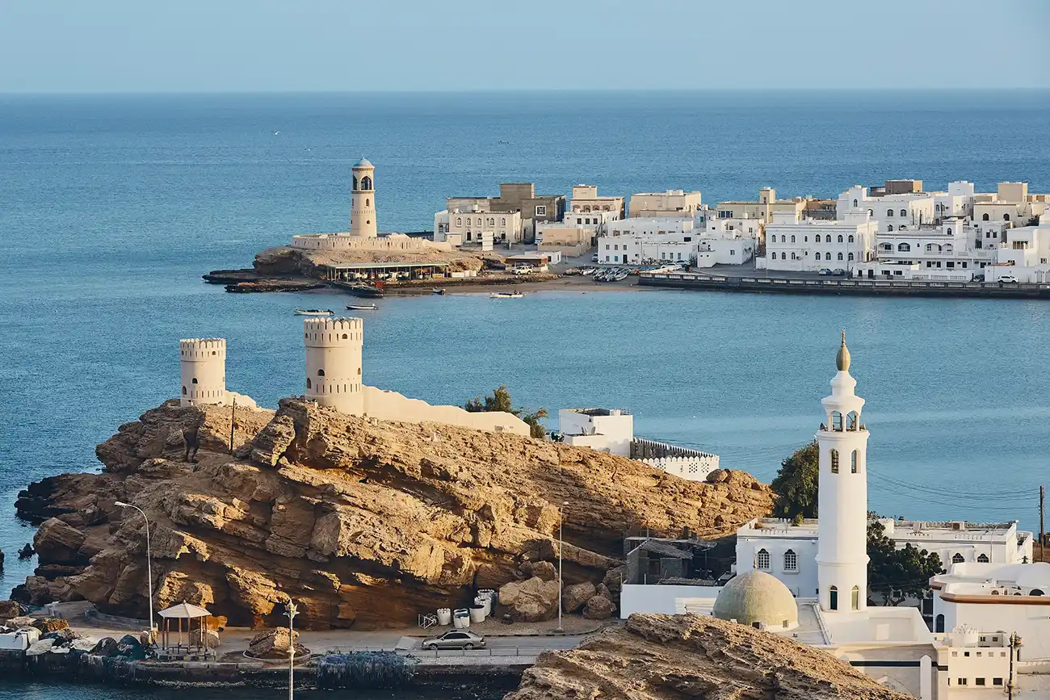

resembles an underwater crater (swimming is possible). Picnic lunch. Continue to Wadi Al Arbeieen, a beautiful wadi with crystal-clear pools, accessible to all, where guests can swim and refresh themselves.

Direct transfer to Muscat Airport for your return flight (from 2000 hrs)

End of services

Package Cost & Important Guidelines

Cost per person in US$:

Travel Period: 01st Sept’25 – 30th Sept’25

HOTEL | PP on DBL Sharing | Single Supplement
Standard Category  Al Falaj Hotel or similar - Muscat  Falaj Daris or similar - Nizwa  Arabian Oryx or simialr – Wahiba Sands  Ras Al Haad Beach Resort or similar - Sur | US$ 1,715.0 | US$ 350.0
Superior Category  Sheraton Oman or similar - Muscat  Golden Tulip or similar – Nizwa  1000 Nights Camp or similar – Wahiba Sands  Sama Ras Al Jinz Resort or similar - Sur | US$ 1,830.0 | US$ 555.0

Travel Period: 01st Oct’25 – 30th April’26

HOTEL | PP on DBL Sharing | Single Supplement
Standard Category  Al Falaj Hotel or similar - Muscat  Falaj Daris or similar - Nizwa  Arabian Oryx or simialr – Wahiba Sands  Ras Al Haad Beach Resort or similar - Sur | US$ 1,715.0 | US$ 350.0
Superior Category  Sheraton Oman or similar - Muscat  Golden Tulip or similar – Nizwa  1000 Nights Camp or similar – Wahiba Sands  Sama Ras Al Jinz Resort or similar - Sur | US$ 2,085.0 | US$ 660.0

Travel Dates (2025):
*2026 – to be advised

RELEASE DATES 2025 (Saturdays):
June / July and August: No departures
September : 05, 19
October : 04, 18
November: 01, 15, 29
December: 13

Inclusions:
- 6 nights accommodation with daily breakfast
- Regular arrival and departure transfers
- Visits according to regular itinerary with a Spanish/Portuguese – speaking guide
- Entrance to designated museums and forts
- Half Board Program
- 5% VAT

Exclusions:
- Personal expenses
- Oman visa
- Optional excursions
- International flights
- No unspecified services
- Tips for driver and guides
- Unspecified foods and beverages
- Upgrade to All inclusive meal plan
Important Guidelines:
- Rooms & Spanish Speaking guide is subject to availability.
- The order of the itinerary may vary, but always keeping all the places to visit.
- All rates are quoted in standard room categoryIn case the mentioned hotel is not available, we will confirm an alternative of the same category.

